**Business Rule**

A department is enrolls multiple students. Each student is enrolled by exactly one department. A department must belongs to exactly one school. A school is consist of many department. A department must have exactly one head of department. A head of department is belongs to exactly one department. A department must employee many faculty. A faculty is employed by exactly one department.

A student is enrolls to exactly one section. Each section must have many students. A faculty is assign to many section. A section must have exactly one faculty. A course is assign to many section. A section must contains exactly one course. A section may assign many assessment. Each assessment is assign by exactly one section.

An assessment is assign to many student. Each student must receive many assessment. An assessment must have multiple Cos. A CO is belongs to exactly one assessment.

A CO is belongs to exactly one course. A course must have many Cos. A CO is belongs to exactly one PLO. A PLO must have many COs.

A PLO is stored by exactly one department. A department must store many PLOs. A PLO is contain by exactly one program. A program must consist of many PLOs.

A program is enrolls many student. Each student is enrolled by exactly one program. A program must belongs to exactly one department. A department is consist of many program.

A school must have exactly one dean of school. A dean of school is belongs to exactly one school. A school must belongs to exactly one university. A university is consist of many school.

A university must have exactly one VC. A VC is belongs to exactly one university.

A student may submit many assessment answer. An assessment answer must submitted by exactly one student. A student must receive grade from exactly one mark sheet. A mark sheet must send grade to many students.

**ERD**

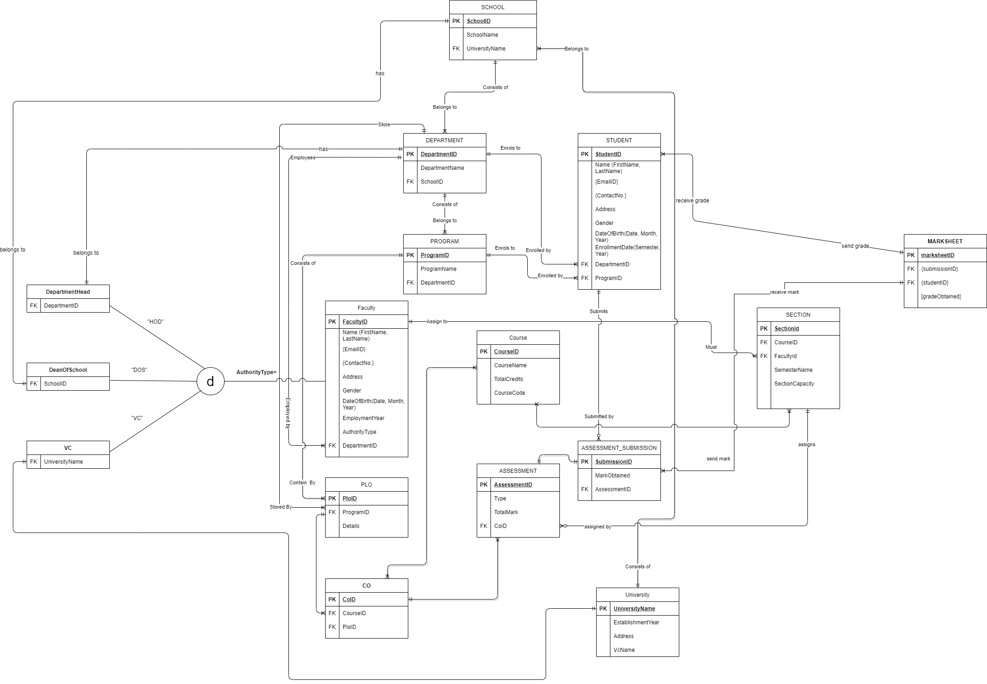

**RELATIONAL SCHEMA**

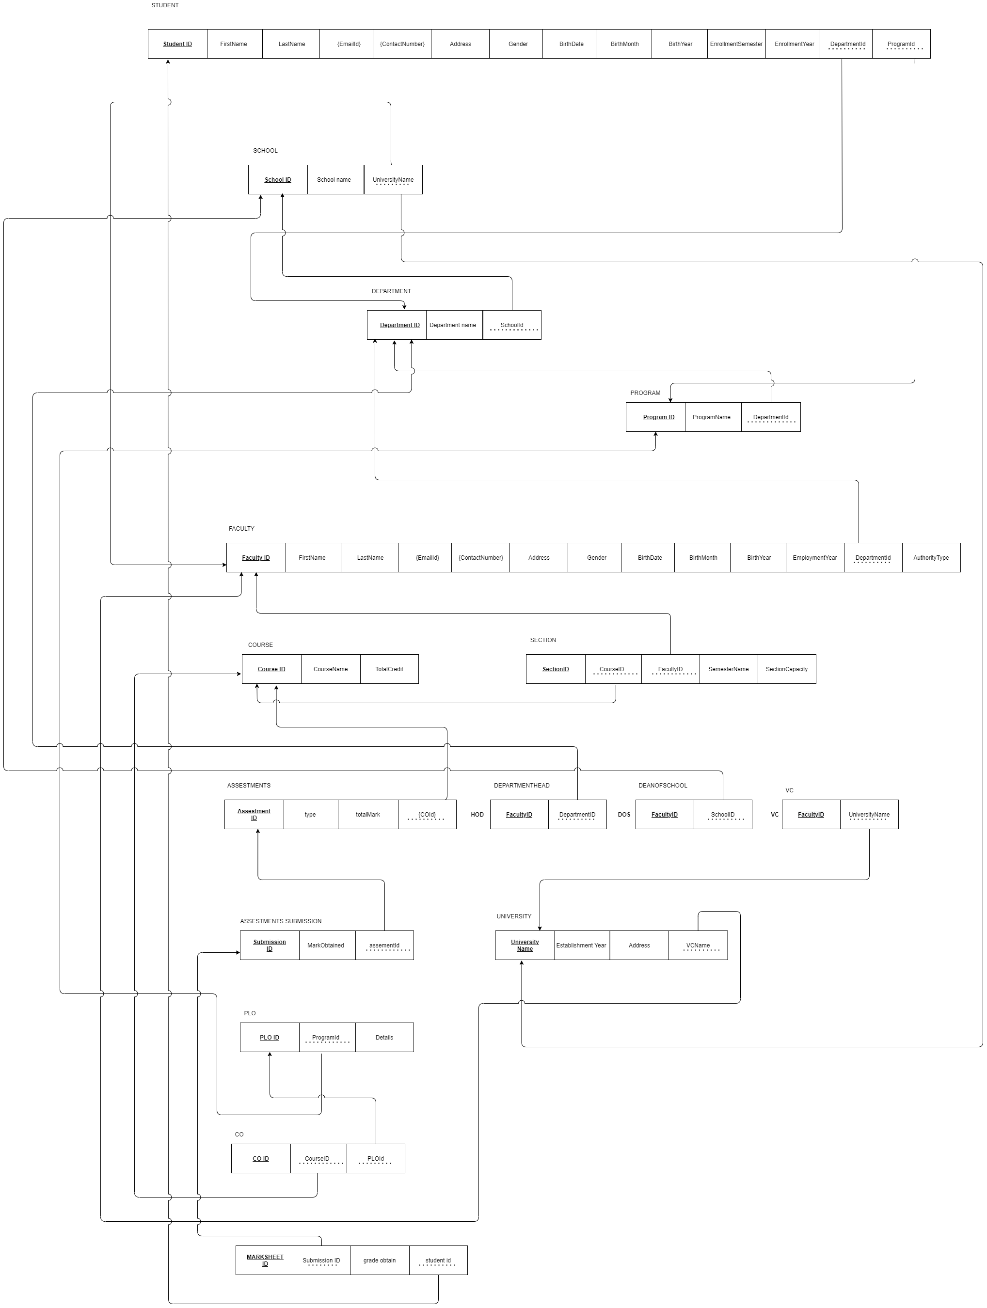

**NORMALIZATION**

**1NF:** In the schema we need to remove all the multivalued attributes.

**2NF:** In thisschema there will be no partial dependencies.

**3NF:** In this schema we have to remove transitive dependencies.

**BCNF:** Remove remaining anomalies resulting from multiple candidate keys.

**DATA DICTONARY:**

tblcourse

|  |  |  |  |
| --- | --- | --- | --- |
| Name | Data type | Size | remark |
| ccourseID | Text |  | This is the primary key of the course. Example:cse303 |
| ccourseName | Text |  | This is the name of the course. example: database management |
| ntotalCredit | Number |  | This is the credit of the course. Example:4 |

tbluniversity

|  |  |  |  |
| --- | --- | --- | --- |
| Name | Data type | Size | Remark |
| cuniversityName | Text |  | This is the primary key and name of the university. Example: Independent University, Bangladesh |
| dEstablishmentYear | Datetime | yyyy | This is the year of Establish the university. Example:1993 |
| caddress | Text |  | This is the address of the university. Example: Plot 16 Block B, Aftabuddin Ahmed Road  Bashundhara R/A, Dhaka, Bangladesh |
| cVCName | Text |  | This is the name of the vice chancellor of the university. Example: Tanweer Hasan |

tblschool

|  |  |  |  |
| --- | --- | --- | --- |
| Name | Data type | Size | Remark |
| cschoolID | Text |  | This is the primary key of the school. Example:SETS |
| cschoolName | Text |  | This is the name of the school. Example: School of Engineering, Technology & Sciences |
| cuniversityName | Text |  | This is the foreign key from the university table. Example: Independent University, Bangladesh |

tbldepartment

|  |  |  |  |
| --- | --- | --- | --- |
| Name | Data type | Size | remark |
| cdepartmentID | Text |  | This s the primary key of the department. example: CSE |
| cdepartmentName | Text |  | This is the name of the department. example: computer science and engineering. |
| cschoolID | Text |  | This is the foreign key from the school table. Example:SETS |

tblprogram

|  |  |  |  |
| --- | --- | --- | --- |
| Name | Data type | Size | Remark |
| cprogramID | Text |  | This is the primary key of the program. |
| cprogramName | Text |  | This is the name of the program. |
| cdepartmentID | Text |  | This is the foreign key from the department table. Example:CSE |

tblstudent

|  |  |  |  |
| --- | --- | --- | --- |
| Name | Data type | Size | Remark |
| cstudentID | Text | 7 | This is the primary key of the student. Example: 1234567 |
| cstudentName | Text |  | This is the name of the student. Example: MR.Abdul Korim |
| cemailID | Text |  | This is the email of student. Example: [abdul@gmail.com](mailto:abdul@gmail.com) |
| ncontractNo | Number | 11 | This is the contract number of the student. Example:01911111111 |
| caddress | Text |  | This is the address of the student. Example: sector6, house 6, road 6 uttara,Dhaka |
| cgender | Text |  | This is the gender of the student. Example:male |
| ddateOfBirth | Date time | dd/mm/yy | This is the birth date of the student. Example:06/06/96 |
| denrollmentYear | Date time | yyyy | This is the enrollment year when the student got admitted in the university. Example:2016 |
| cdepartmentID | Text |  | This is the foreign key from department table. Example:CSE |
| cprogramID | Text |  | This is the foreign key from the program table. |

tblfaculty

|  |  |  |  |
| --- | --- | --- | --- |
| Name | Data type | Size | Remark |
| cfacultyID | Text | 5 | This is the primary key of the faculty. Example:11111 |
| cname | Text |  | This is the name of the faculty. Example: MR.gousul azom |
| cemailId | Text |  | This is the email address of the faculty. Example:gousul@gmail.com |
| ncontractNo | Number | 11 | This is the contract number of the faculty. Example:7654321 |
| caddress | Text |  | This is the address of the faculty. example:sector5,read5, house 5 uttara, dhaka |
| cgender | Text |  | This is the gender of the faculty. Example:male |
| ddateOfBirth | Date time | dd/mm/yy | This is birth time of the faculty. Example: 11/12/66 |
| demploymentYear | Date time | Yyyy | This is the employment year when the faculty joined as employee in the university. Example:2009 |
| cdepartmentID | Text |  | This is the foreign key from the department table. Example: CSE |

tblsection

|  |  |  |  |
| --- | --- | --- | --- |
| NAME | DATA TYPE | SIZE | REMARKS |
| csectionID | Text |  | This is the primary key of the section. Exmaple: CSE 303 SEC 01 |
| ccousrseID | Text |  | This is the foreign key from the course table. Example: cse301 |
| cfacultyID | Text |  | This is the foreign key from the faculty table. Exmaple:11554 |
| csemesterName | Text |  | This is the name of the semester. Example: Spring 2016. |
| csectioncapacity | Number |  | This is the total capacity of a section. Example: 30. |

tblplo

|  |  |  |  |
| --- | --- | --- | --- |
| NAME | DATA TYPE | SIZE | REMARK |
| cploID | Text |  | This is the primary key of the PLO(Program Learning Outcome). Example:”PLO1” |
| cprogramID |  |  | This is the foreign key from the program table. Example: M.sc. |
| cdetails | Text |  | This is the details of the PLO. |

tblco

|  |  |  |  |
| --- | --- | --- | --- |
| NAME | DATA TYPE | SIZE | REMARKS |
| ccoID | Text |  | This is the primary key of the CO. Example “CO1” |
| ccourseID | Text |  | This is the foreign key from the course table. Example:”CSE303” |
| cploID | Text |  | This is the foreign key from the PLO table. Example: “PLO2” |

tblassessmentID

|  |  |  |  |
| --- | --- | --- | --- |
| NAME | DATA TYPE | SIZE | REMARKS |
| nassesmentID | Text |  | This is the primary of the assessment. |
| ctype | Text |  | This is the type of the assessment. |
| ctotalMarks | Number |  | This is the semester of the Enrollment. |
| ncoID | Text |  | This is foreign key of the course. |

tblassessment submission

|  |  |  |  |
| --- | --- | --- | --- |
| NAME | DATA TYPE | SIZE | REMARKS |
| nsubmissionID | Text |  |  |
| cmarkObtained | Number |  |  |
| nassessmentID | Text |  | This is foreign key of the assessment ID. |

tblmarksheet

|  |  |  |  |
| --- | --- | --- | --- |
| NAME | DATA TYPE | SIZE | REMARKS |
| cmarksheetID | Text |  | This is the primary key of the marksheet ID. |
| submissionID | Text |  | This is the foreign key of the submission ID. |
| cstudentID | Text |  | This is the foreign key of the student ID. |
| cgradeObtained | Number |  |  |